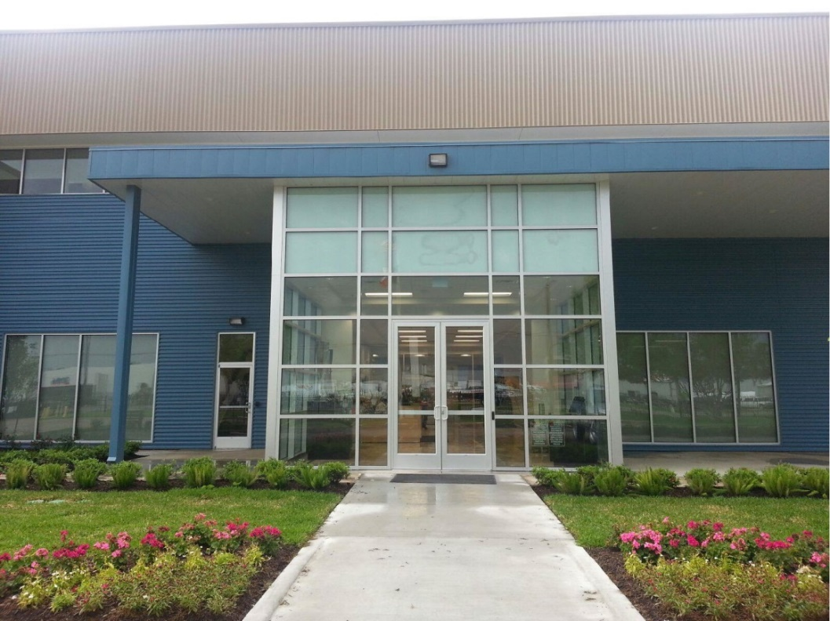

Houston Learning Center
Instructor Addendum

Table of Contents
Arrival at the HLC 3
Primary Point of Contact for Issues 4
Safety Video 7
PPE (Personal Protective Equipment) 8
(POWRA) Point of Work Risk Assessment 8
Customer Tours/Walkdowns 8
Printer(s) 9
Facilities Issues 10
Operating the AV system in 1233/1235 and 1128-1131 in Building 1 11
Office Supplies and PPE 15
End-of-Class Classroom Checklist for Instructors 16

Arrival at the HLC
Houston Learning Center COVID-19 Protocols
Upon arrival at the HLC for the first time check in with the gate guard and park in the visitor parking. Proceed to the security desk in the lobby and ask security to contact your PLL. Your PLL will assist in issuing you a blue HLC staff badge allowing you access to the facility and directing you to your classroom or lab area. If your PLL is not available, ask security to contact any of the PLLs or Training Delivery Manager. Once checked in please move your vehicle from visitor parking to the staff parking lot on the East side of the facility behind Building 1.
If you have previously been to the HLC and already have a blue HLC staff badge, you may proceed directly to the staff parking lot after checking in with the gate guard. Please contact your PLL upon arrival to let him/her know you are onsite and for further direction.
Your blue HLC staff badge will give you access to the facility 24/7. If you do not have a blue HLC staff badge, you will need to contact your PLL. HLC business hours are Monday – Friday, 7:30 am – 4:30 pm.

- The digital version of this document is located here: https://ge.box.com/v/HLCInstructorAddendum
- The full version of the HLC Guidebook can be found here: https://ge.box.com/v/HLCGuidebook2017
- The HLC utilizes a customized app to provide information about the facility, recommended hotels, restaurants and activities. We will also use the app to communicate important information while you are here. Please download the app here: Apple: http://bit.ly/2fVZKi3 Android: http://bit.ly/2f4NQBA

Primary Point of Contact for Issues
Once class begins, you should be the primary point of contact to escalate anyissues while at the HLC or need support, please reference the chart below for determining who your primary point of contact is for various needs. If 2 names are listed, you may reach out to either person.
Issue | Internal |  |  | Customer
Issue | FE | OSS/Repairs | Craft | Open Enrollment | Site Specific
Technical | PLL |  |  |  |  | Training equipment, simulation, training content, etc.
Student Issue | PLL/Andrew Ruch |  |  | PLL/Maria Medina | PLL/SS PM | Student behavior issue (not showing up), medical (COVID), car accident, passport stolen, etc.
Logistical | Mari Guidry |  |  | Maria Medina | John Douglas | General logistical/housekeeping issues - Need office supplies, print certificates or handouts, locate manuals, catering/Abby's cards, etc.
Facility | Steve Urban/ Yegor Spencer |  |  |  |  | Issues with the facility - HVAC, projectors, lights, elevators, internet, housekeeping issues, etc.
EHS | Lizlee Galley/PLL

Role | Contact Name | Email | Phone #
EHS | Lizlee Galley | Lizlee.galley1@ge.com | +1 (346) 324-1774
PLL | Michele Alcantar | Michele.Alcantar@ge.com | +1 (832) 926 0238
PLL | Harry Hanson | harry.hanson@ge.com | +1 (630) 561 5231
PLL | Pablo Schibli | pablo.schibli@ge.com | +41 (79) 8787173
PLL | Sherif Khalifa | Sherif.Khalifa@ge.com | +1 (281) 387 4979
PLL | Greg Walker | GregoryD.Walker@ge.com | +1 (936) 520 0397
PLL | Mohammed Nizami | Mohammed.Nizami@ge.com | +1 (281) 7442541
SS PM | Pat Molumby | patrick.molumby@ge.com | +1 (518) 810 2799
SS PM | El Mansoor Abuobaida | abuobaida.elmansoor@ge.com | +971 (52) 8007191
SS PM | Alejandra Saldana | Alejandra.Saldana@ge.com | +52 (442) 3379499
OE PM | Maria Medina | maria.medina@ge.com | +1 (713) 597 1935
SS PM | Anna Petrella | anna.petrella@ge.com | +41 (79) 5710279
Logistics | Andrew Ruch | Andrew.Ruch@ge.com | +1 (281) 229 5417
Logistics | Mari Guidry | Marisol.Guidry@ge.com | +1 (832) 998 4104
Logistics | John Douglass | John.Douglas@ge.com
Facilities | Steve Urban | stephen.urban@ge.com | +1 (862) 210 5487
Facilities | Yegor Spencer | Yegor.Spencer@ge.com | +1 (409) 766 0179
*For Urgent issues, contact via phone number (call or Text)
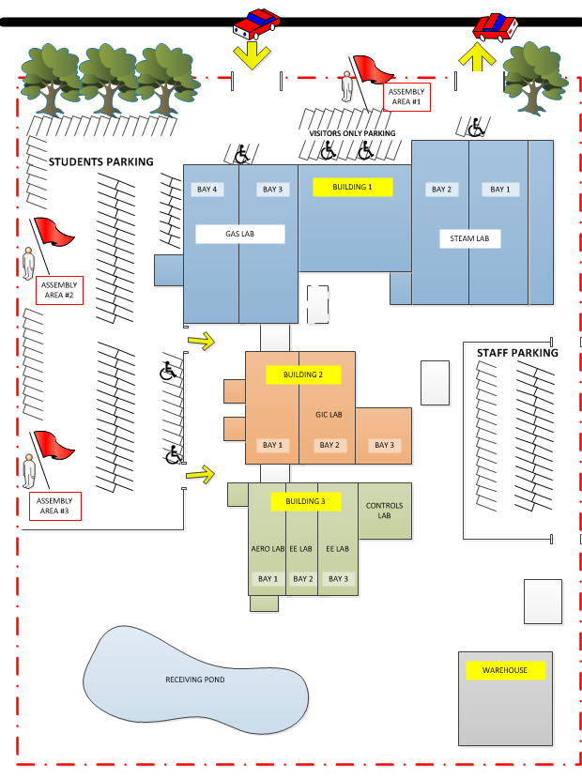
Smoking Area
Dumpster
Key Contacts - Training
Training Delivery Manager - Jim Rosen | (832) 714 2496
Controls
Product Line Lead – Mohammed Nizami | (281) 7442541
Jim Lin | (281) 254 1472
John Doss | (281) 384 0888
Gas Turbine
Product Line Lead – Sherif Khalifa | (281) 387 4979
Jimmy Capps | (936) 222 9713
Greg Jackson | (281) 658 8433
Gary Franklin
Steam Turbine
Product Line Lead – Pablo Schibli | +41 (79) 8787173
Aaron Curtis | (361) 816 8194
Rene Rivas
Marcela Bohorquez | (346) 453 8130
Excitation/Generator
Product Line Lead - Michele Alcantar | (832) 926 0238
Ben Smith | (513) 646 5243
Vince Bionidi
Julio Ramirez Rojas | (281) 254 5589
Willy Bueno
Aero
Product Line Lead – Greg Walker | (936) 520 0397
Roland de Conceicao | (713) 672 3771
Douglas Salazar | (832) 606 8779
Richard Fisher
Craft/Repairs
Product Line Lead – Harry Hanson | (630) 561 5231
Victor Fuentes | (281) 217 5421
Lucien Cote | (603) 631 5216
Hector (Lou) Baez | (813) 389 8810
Matt Remillard

Key Contacts - Logistics
Global Logistics Leader - Andrew Ruch | (281) 229 5417
OE Project Manager – Maria Medina | (713) 597 1935
Training Coordinator Internal Enrollment – Marisol Guidry | (832) 998 4104

Safety Video
The safety video MUST be shown to all incoming students on the first day of class before the start of technical training. The video is approximately 11 minutes. Students who show up after the start of class will be shown the video by security.
The safety video is in GE box:
https://ge.ent.box.com/file/280482563214
If you do not have access to the GE Box folder contact Jim Rosen (jim.rosen@ge.com) and inform your PLL immediately. It is recommended you verify access prior to your arrival at the HLC.
To play the video, click the link above. The video will open in preview mode. Click play, and then click Enter Full Screen:
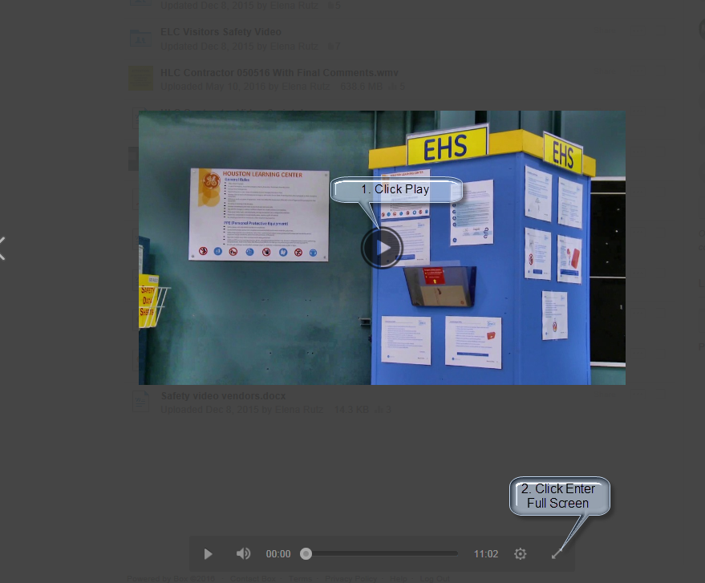
NOTE: In order for the sound to work, you must have an HDMI or mini display port on your laptop. If you need assistance with the safety video, please contact HLC IT or your PLL.
NOTE: HLC IT has copies of the video on USB thumb drives and DVD if you experience issues with internet connectivity from GE Box.

PPE (Personal Protective Equipment)
PPE will be worn when necessary to protect employees and students against hazards that cannot be practically eliminated or controlled. Whenever there is a change in working conditions that presents new or different hazards, the Instructor or Supervisor will ensure that work areas and tasks are reassessed to identify any new PPE requirements and will provide suitable protection as necessary. Where PPE is specified, compliance with its use is mandatory. All employees who use PPE will receive appropriate training on PPE selection, use, care and maintenance.
- Safety glasses with side shields must be worn at all times in training bays and lab areas.
- Substantial footwear (a shoe that completely encloses the foot) must be worn at all times in training bays and lab areas even within the yellow lines.
- Safety shoes must always be worn outside the yellow lines.
- Hard hats must be worn when overhead work is being performed.
- Additional PPE such as hearing protection, gloves, and additional eye protection must be worn in designated areas or when performing designated tasks.
- Refer to the Safety Risk Assessment (SRA) for the task you are performing to determine the required PPE.


- Do not wear clothing or jewelry which could get caught in machinery or otherwise cause accident or injury.
When entering the lab areas, you will see PPE requirements posted on the door. Please read those and comply. You will find boxes with safety glasses in various locations, so you can always wear an eyewear if you forgot yours.

(POWRA) Point of Work Risk Assessment
A POWRA must be developed and made available for each job task performed at HLC. This is intended to analyze the task at hand to analyze the best method to perform the task safely. It includes both routine and non-routine tasks and activities. We find when we review and plan for a task, we stay safer - whether it is routine or non-routine. The use of these STAs has proved very beneficial and works - please use them! Upon completion of your task please return POWRAs back to EHS Manager, Facility Manager or your PLL.

Customer Tours/Walkdowns
When conducting tours or equipment walkdowns for customers/students, the students MUST be always escorted by HLC employee or Instructor. An evaluation of ongoing work and risks in the area must be completed by the instructor prior to bringing students into training bays or lab areas and all required PPE shall be worn at all times. Customer/Students should not be operating or manipulating any parts, tools or equipment unless they are properly trained and authorized to do so. If you have any questions or need assistance with tours/walkdowns, contact HLC EHS manager or your PLL.

Printer(s)

If you can access the BLUESSO Network, click on the link to the print server below to install a printer.
\\avnfwp0237v02
On the resulting window, listed in alphabetical order, find HLC_Xerox_BLDG_1_Color and double click its icon.
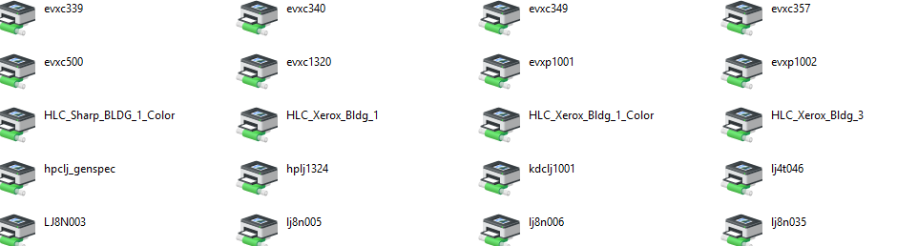

The connection will begin and install the print driver as in the example below.
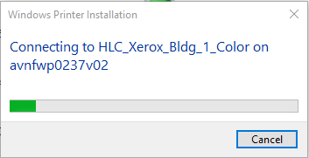

Finally, you will see this window completing the installation.
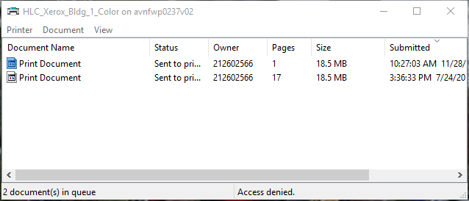
To install additional printers, use the link above to the print server and search for the desired printer, then follow the same steps as above:
HLC_Xerox_Bldg_1 (B&W printer Bldg 1, first floor)
HLC_Xerox_Bldg_3 (B&W printer Bldg 3, second floor)

For directions to install the student printer, see the HLC Guidebook page 26.

Facilities Issues
For any facilities related requests such as classroom set up, HVAC issues, broken equipment, etc. there is a maintenance request work flow located on the GP Training Operations Quicklinks Site:
https://app.sc.ge.com/sites/1567233/portal/1043228
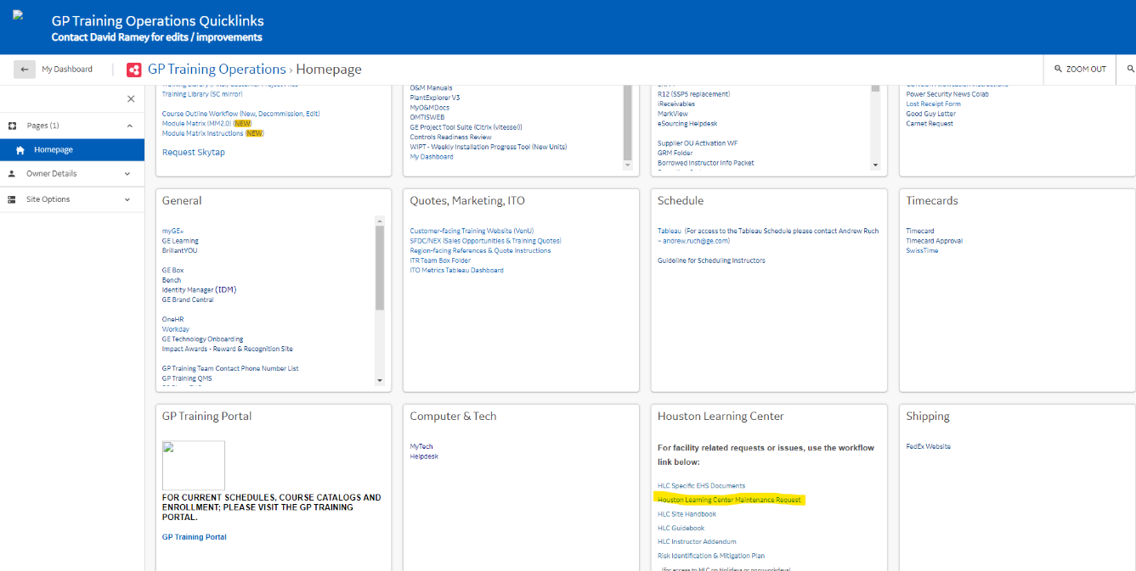
https://app.sc.ge.com/workflows/initiate/801910
Please follow up any immediate needs with Steve Urban and your PLL. For immediate needs, contact facilities first and submit the work flow when time permits.
Steve Urban – 1-862-210-5487
Yegor Spencer – 1-409-766-0179
Boyce Hernandez – 1-832-339-3500

Operating the AV system in 1233/1235 and 1128-1131 in Building 1
NOTE: You must have an HDMI output on your laptop. If you do not, contact HLC IT or your PLL for the appropriate adaptor.
Crestron Panel
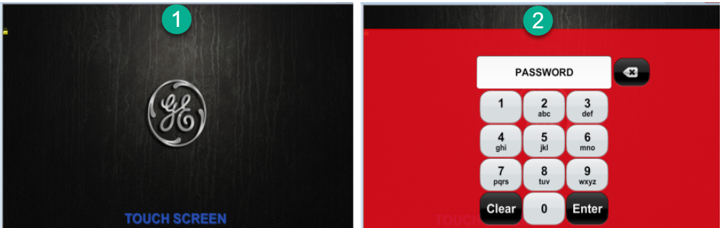

- Touch anywhere on GE logo screen.
- Press 1234 and Enter.

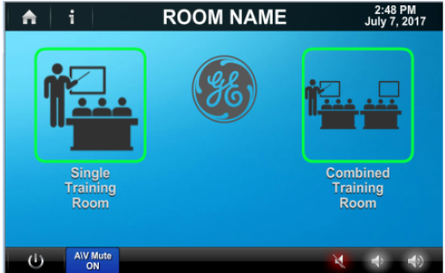
Press Single or Combined to set room configuration.
When selecting Combined, both projectors power on. When selecting Single, each projector powers on when a Source is selected.

Source Selection
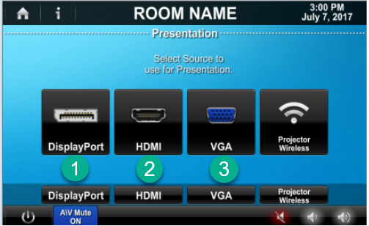
- Select DisplayPort to view the tower PC (HMI) at the instructor’s desk.
- Select HDMI for HDMI connected laptop
- Select VGA for VGA connected Laptop
GE Laptop
Verify:
(A)HDMI (preferred connection) OR (B)VGA cable is connected to HDMI/VGA port on laptop
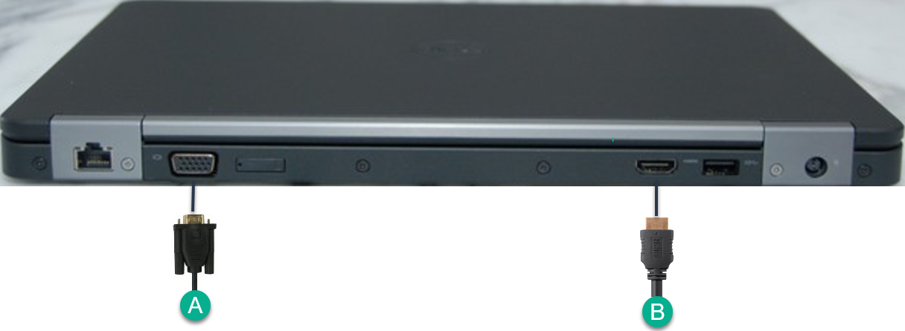


Verify: Laptop is synced to the projector. Sync the projector and laptop by holding down the FUNCTION key Function Key and pressing one of the following keys to toggle: 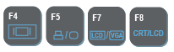
Select “Duplicate”

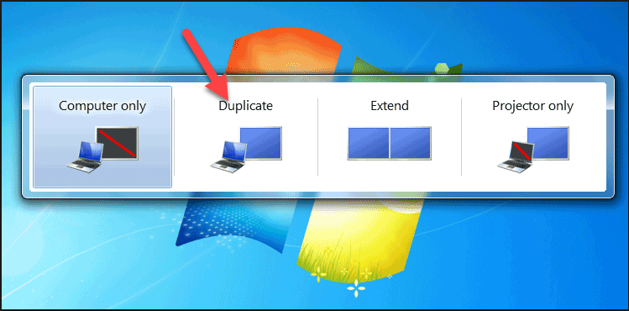
Crestron Switcher (Rear)
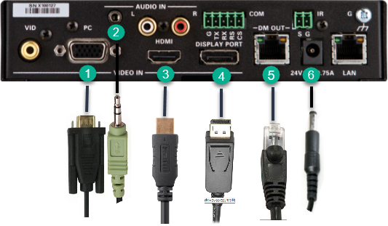
- Verify VGA cable is connected
- Verify Audio cable is connected
- Verify HDMI cable is connected
- Verify Display Port cable is connected
- Verify data cable is connected
- Verify power cable is connected

Crestron Switcher (Front)
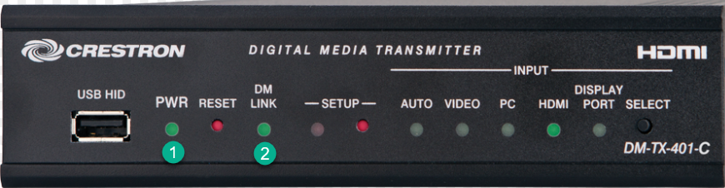
- Verify PWR light has a solid green light
- Verify DM LINK light has solid green light (no DM Link light equals NO VIDEO)

Crestron Switcher to Wall plate
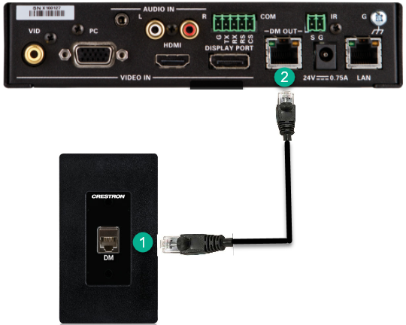

- One end of Ethernet cable should be plugged into the black wall plate
- The other end of the Ethernet cable should be plugged into DM OUT port

Office Supplies and PPE

There are three (3) self-serve locations for office supplies and PPE at the HLC:
- Building 1 Lobby:
Provides common office supplies, including dry erase markers, pens, paper, and hand sanitizer. PPE items like gloves, safety glasses, shoe covers, hard hats, and masks are also available. Note: Hard hats and overshoes are for temporary use and must be returned after use. For access or to request more, see security personnel at the front desk..

- Building 1, Second Floor, Room 1202:
Exclusively contains office supplies and is accessible with your employee badge.

- Classroom Cabinets:
Each classroom has a black cabinet stocked with basic supplies like note pads, pens, name tags, and attendance sheets. Passcodes are:
- Building 1: 1234
- Building 2: 2345
- Building 3: 3451
Cabinets are for classroom supplies only. Please don’t share passcodes with students or use the cabinets for storage. For access issues, contact Boyce Hernandez, and for restocking, reach out to Chanelle Williams.

If you cannot find what you need or have any questions regarding how to obtain office supplies or PPE while at the HLC, please contact your PLL, Facilities or the front desk.

End-of-Class Classroom Checklist for Instructors

Equipment
- Whiteboard/Flip Charts: Erased and cleaned.
  - Action: If markers or erasers are missing, notify Facilities
- Projector/Smartboard: Turned off and screen retracted.
  - Action: Report any technical issues to the IT department.
- Laptops: Closed, unplugged, and stored securely.
  - Action: If laptops are malfunctioning, inform PLL.
- Props/Training Aids: Accounted for and stored neatly.
  - Action: Replace any damaged or missing props.

Classroom Arrangement
- Tables: Aligned straight and neatly arranged.
- Chairs: Pushed in.

Sensitive and Specialized Materials
- Training Manuals: Collected and stored securely.
- Proprietary Software/Simulators: Logged off or shut down.
- Machinery: Turned off and secured.
  - Action: Report any machinery faults or issues to PLL.

Cleanliness and Sanitization
- General Area: Free from clutter; nothing left on the floor.
- Tables: Free from materials to allow for cleaning.
- Instructor Podium: Clear of any materials.
- Trash Bins: Not overflowing.
  - Action: If bins are full, empty them in the dumpster located behind Building 1.

Security
- Doors and Windows: Locked and secured.
- Equipment: Stored safely and securely.
- Lights: Turned off.

